LAND SUBSIDENCE: THAT SINKING FEELING
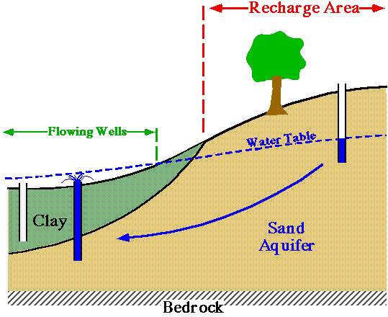Humans are usually the culprits in causing land subsidence. When we pump out large amounts of water for cities or for agriculture we can cause dramatic sinking. Groundwater removal from unconsolidated sediments may result in sediment compaction as pore spaces collapse when water is withdrawn. This can cause subsidence, or sinking, of the ground surface. In figure 1 to the right, you see an artesian well flowing from a sand aquifer. As the water leaves the sand and empties the pore space, the sand compacts.
Figure 1. Artesian Well Causing Land Subsidence
Land subsidence because of withdrawal of ground water is a serious problem. Obviously, in coastal areas subsidence can mean that the land surface drops below sea level. In the Santa Clara Valley of California, some 17 square miles are now below the highest tide level in San Francisco Bay and must be protected by earthwork damns. Subsidence in cities like Houston causes serious flooding problems, especially during heavy rain events like hurricanes. Other centers of subsidence include Mexico City, Tokyo, and Las Vegas. With increasing withdrawal of groundwater and more intensive use of the land surface, the problem of subsidence may be expected to become more widespread.The most famous case of land subsidence is in Pisa, Italy. The Leaning Tower of Pisa was built on soft, river valley sediments. Since the tower was built in 1174 AD, it has been sinking an average of 1 millimeter per year. In order to arrest the sinking and prevent the Leaning Tower from toppling over, modern engineers have worked to develop a plan of injecting cement into deep cores below the tower to firm up its footing. Interestingly, the Italian government has decided not to straighten the Leaning Tower, but to just prevent it from any further sinking.
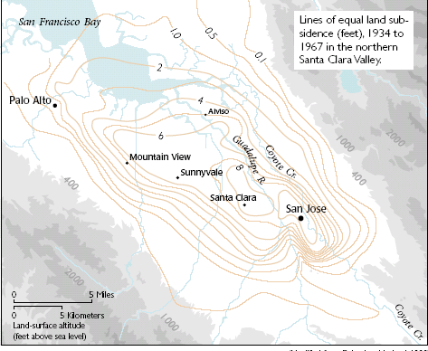
Other cities have instituted plans to prevent land subsidence. Santa Clara, California has limited the amount of pumping from the water table aquifer to prevent further compaction and imports water to inject back into the aquifer. Arizona and Texas have both established new groundwater policies that address the problem of subsidence. Table 1 below shows data from a USGS data point located in San Jose. The total sinking from 1912 to 1967 was 12.7 feet. Recharge measures were enacted in 1967 to arrest any further subsidence.
Figure 2. Sinking in Santa Clara Valley from 1934-1967. Gray Areas = Consolidated Rocks
Table 1. Subsidence at Benchmark 7 in San Jose
Year | Subsidence (feet)
1912 | 0.0
1920 | 0.3
1934 | 4.6
1935 | 5.0
1936 | 5.0
1937 | 5.2
1940 | 5.5
1948 | 5.8
1955 | 8.0
1960 | 9.0
1963 | 11.1
1967 | 12.7

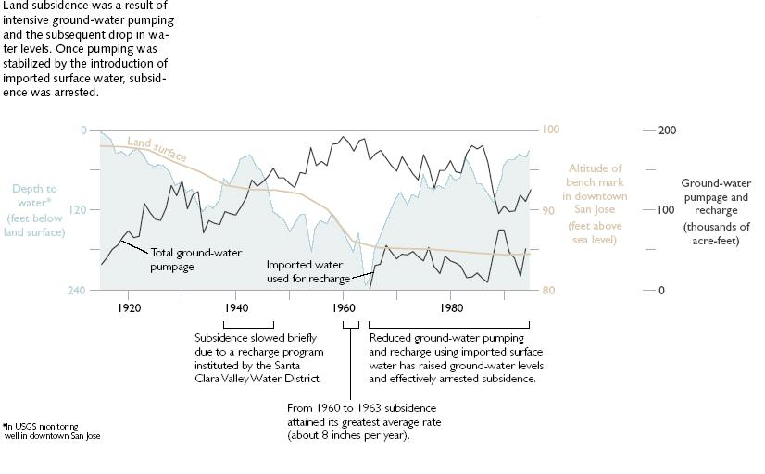
Figure 3. Hydrograph of Subsidence in San Jose
Analysis Questions
- What cities have suffered the greatest subsidence in the Santa Clara Valley?

- Using the data in Table 1, what was the total subsidence in San Jose from 1934 to 1967?

- What was the average annual rate of subsidence for this same period of time?

- Describe the problems that people in the Santa Clara Valley may have had because of subsidence.

- Would you expect subsidence to occur in the consolidated rocks shown on the map? Explain why or why not.

- Examine the hydrograph (Figure 3). What years were the wells artesian (flowing without being pumped)?

- What is the explanation for the minor fluctuations in the hydrograph (Figure 3)?

- Why did the subsidence stop in the Santa Clara Valley in 1967? What might that mean for cities like Houston and Las Vegas?

