Annual 8th Grade Greenbelt Experience

Name___________________________________

Science Teacher__________________________

GREENBELT EXPECTATIONS

Expectations:
Chaperone Expectations | Student Expectations
- Use the field guide provided and help students observe freshwater resources  - Keep students safe and together at all times  - Enforce student expectations  - Notify a teacher in case of an emergency or behavior issue  - Have fun! | - Respect chaperones and follow directions at all times  - Stay within earshot and eyesight of your chaperone  - Keep all electronic devices out of sight  - LEAVE NO TRACE: Respect nature and leave the environment as you found it. No littering or picking up rocks!!!  - Use trail etiquette and respect other hikers by speaking at a low volume and moving to the right (single file) to allow bikers/hikers to pass your group

Brief Field Guide
- All groups will hike 2 miles out and 2 miles back for a total of 4 miles.
- Follow the trail head from Barton Springs pool. You will come to a fork in which you will see fencing on the ground to the left and to the right, if you look up you will see a house with white fencing on a cliff. The water at this site is Campbell’s hole.
- Continue on the trail passed the rock climbing walls to Gus Fruh park access.
- Continue to the 2 mile marker.
- Head back in the direction you came from toward the buses for Lunch!

Bus Group | Order of Stops
1 | 1,2,3,4
2 | 2,3,4,1
3 | 3,4,1,2
4 | 4,1,2,3

GREENBELT STOPS

Stop 1: Entrance to Barton Creek Greenbelt
- As students begin their hike, have them keep an eye out for fossils
- Students may sketch any fossils seen along the way and we will identify them in class.

Stop 2: Campbell’s hole
- A popular swimming hole and great place to see the rocks that make up the upper third of the Edward’s Aquifer
- These rocks were laid down about 100 million years ago when a shallow inland sea covered much of Texas
- Water in this area was very shallow and extended for hundreds of miles across Texas
- A large coastal reef blocked wave action from disturbing the central Texas area between Austin and Houston.
- Shelled organisms used minerals such as calcite dissolved in the water to produce larger, harder shell structures.
- Many of these are found in the fossiliferous bedrock we are hiking on today. Faults throughout the rock formations allow for water to flow directly to the Edward’s Aquifer.

Fossil Sketches:

Stop 3: Barton Springs Pool:
- How many springs make up “Barton Springs”?

- Why don’t we use Barton Springs as a drinking water source?

- What will be the downfall/cause of problems in Barton Springs?

- Why are the Barton Spring Salamander and the Austin Blind Salamander so carefully monitored?

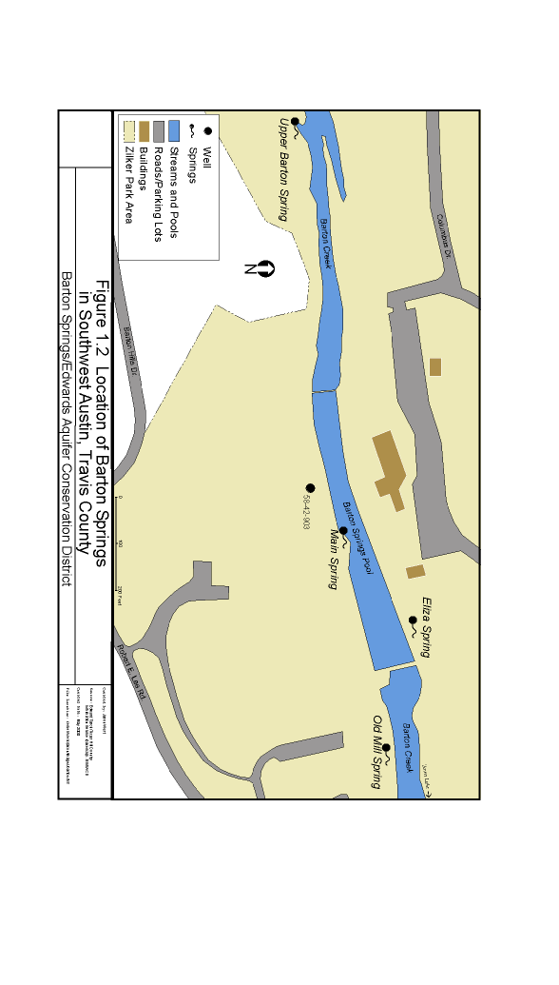
- In the future, what will determine the success of these salamanders in Barton Springs?

- How do these salamanders breathe? How will over pumping of the springs cause a problem for them?

- Barton springs is made up of 4 springs, 3 of them named for the daughters of the original owner, William Barton. The main spring Parthenia Spring discharges into the Barton Springs pool near the diving board. Zenobia springs, located in the sunken gardens southeast of the main spring, is also called Old Mill Springs. In 1879, there was a three story-tall flour mill built on the site. Eliza spring is founds behind the concession stand north of the pool. The fourth spring on the south bank, is upper barton spring. This spring only flows when the other three are overflowing.
- In extreme drought conditions, Barton Springs could possibly run dry until replenished by rainfall. Pumping from the spring’s discharge can also dry up parts of the Recharge Zone.
- The 1st recorded contamination was reported in 1922 and was due to many habitations and the long distance that the water flows at a shallow depth. In the early 1900s bacterial contamination was found to have originated from human refuse. Since then Barton Springs was found too sensitive to be relied on for regular drinking water
Stop 4: Eliza Springs
- Over pumping of water could cause the habitats of the barton springs salamander to dry up and development increases pollutant runoff which degrades the water quality of the springs

POINT SOURCE VS. NON-POINT SOURCE POLLUTION

We are hiking as part of our study on water pollution and conservation. As you move walk through each of the stops, look for signs of point source and non-point source pollution (NPS). As defined by the Environmental Protection Agency (EPA), NPS pollution is caused by rainfall or snowmelt moving over and through the ground. As the runoff moves, it picks up and carries away natural and human-made pollutants, finally depositing them into lakes, rivers, wetlands, coastal waters, and even our underground sources of drinking water. These pollutants include:
- Excess fertilizer, herbicides, and insecticides from agricultural lands and residential areas;
- Oil, grease, and toxic chemicals from urban runoff and energy production;
- Sediment from improperly managed construction sites, crop and forest lands, and eroding streambanks;
- Salt from irrigation practices and acid drainage from abandoned mines;
- Bacteria and nutrients from livestock, pet wastes, and faulty septic systems

NPS pollution Observed:

The EPA defines point source pollution as “any single identifiable source of pollution from which pollutants are discharged, such as a pipe, ditch, ship or factory smokestack”

Point Source Pollution Observed:

Glossary Of Terms

Aquifer: a permeable formation that stores and moves groundwater in large amounts to supply wells.

Artesian Zone: an aquifer containing water under pressure.

Brachiopod: any mollusk-like, marine animal of the phylum Brachiopoda, having two shells; a lampshell.

Breccia: a rock composed of angular fragments of older rocks cemented together.

Calcite: a common mineral made of crystallized calcium carbonate (CaCO₃); a major component of limestone.

Carbonates: sediment or sedimentary rock formed by the precipitation of carbon from a liquid solution of carbonates of calcium, magnesium, or iron. Limestone is an example of a carbonate rock.

Carbonic Acid: A weak, unstable acid (H₂CO₃), produced by carbon dioxide dissolved in water.

Chert: a sedimentary form of fine-grained quartz rock, found in concretions and in beds of rocks.

Contributing Zone: a zone of the Edward’s Aquifer where water that runsoff from the land feeds streams that flow over impermeable limestone until they reach the recharge zone.

Fossiliferous: containing fossils.

Impervious Cover: a groundcover that water cannot flow through.

Indicator Bacteria: bacteria used to determine the quality of the water at a source.

Internal Drainage: an area of land where no runoff flows to a creek, stream, or lake, but soaks into the ground to become ground water recharge.

“The Unforeseen” Video Viewing and Analysis
“The Unforeseen” Video 9:35-11:00 AM
Students will view a video about the controversial environmental issues that led to the creation of the Save Our Springs (SOS) movement in Austin, Texas.
Film Description from the PBS program “NOW”: http://www.pbs.org/now/shows/324/index.html
“In the 1970’s and 80’s, Land Developer Gary Bradley worked to transform Austin, Texas’ pristine hill country into lucrative residential subdivisions, making both headlines and lots of money. When local residents learned of new plans to develop 4,000 acres over nearby Barton Creek, they rose up to stop Bradley and his partners in their tracks. Whereas the developers had strong connections in the Texas Legislature—and a powerful ally in eventual Governor George W Bush—the city had an even stronger connection to their unspoiled home. “The Unforeseen” captures the drama, passion, and heartfelt convictions on all sides of the conflict without making easy targets of any of them.”
Answer the following questions as you watch the video:
Question | Notes | Final Answer
1. What is SOS? What is their “mission”?
2. Briefly describe the hydrology issues as well as the social, political and economic issues facing the Edwards Aquifer.
3. Describe the roles of these individuals:
a. Gary Bradley
b. Willie Nelson
c.Ann Richards
d. Robert Redford
e. GW Bush
4. How does the film attempt to not make “easy targets” of the various people on both sides of the conflict?
5. How has SOS contributed to Austin/Central Texas’ protection of the Edwards Aquifer?

Boggy Creek Water Quality Rotation Guide
Each Activity will Take between 30-40 minutes
Activity 3 and 4 can be combined if necessary

Groups | Station to Start With
Super Group 1 | 1,2,3,4
Super Group 2 | 2,3,4,1
Super Group 3 | 3,4,1,2
Super Group 4 | 4,1,2,3

Station 1: Rosewood Park: History of Boggy Creek Neighborhood/Madison Cabin

Rosewood Recreation Center now sits in the middle of the old Bertram-Huppertz place, which Rudolph Bertram acquired in 1875. The older portion of the building was the residence of Mr. Bertram who was a local storeowner in 1921; 17 acres were sold to the City of Austin after Charles Huppertz, Mr. Bertram's son-in-law died. In 1929, an after-school playground and Center program began at Rosewood. The Parks and Recreation Department developed the land and park in the 1930's. Tennis courts, picnic area, bandstand, baseball field and open spaces were available to the public.
Doris Miller Auditorium was constructed in 1942 for the recreation needs of the Armed Forces and USO programs. In the 50's, "teen cantina" is fondly remembered by East Austin residents. The facility was named after Doris "Dorie" Miller, a hero at Pearl Harbor, and the first African American recipient of the Navy's the highest honor, the Navy Cross. He served in the U.S. Navy and was recognized for his great heroism during the attack on Pearl Harbor. Miller was presented the Navy Cross by Admiral Nimitz on May 27, 1942. He died shortly after this in 1943 in the sinking of an aircraft carrier in the Pacific.
A HUD-Model Cities grant made possible the latest expansion of the Rosewood Recreation Center and the improvements to Doris Miller Auditorium. With the addition of the Madison Log Cabin, Rosewood Park and Recreation Center is a warm contrast of history and modern facility which adds to the recreation opportunities and development of its community.
The historic log cabin, a gift from Mrs. Greenwood Wooten, has been furnished by Delta Sigma Theta. The cabin serves as museum preserving historical relics and documents related to the Black Heritage of Austin and Travis

Students are to view the historic cabin, and the Rosewood Recreation Center.
Topics | Your Notes
Observations of amenities in the park
History of the cabin
History of the recreation center/ball fields
Sketch the cabin as well as possible uses of the land surrounding the (relocated) cabin.

“A History of the Blackland Neighborhood of East Austin” By Bo McCarver, Ph.D.
In the decades after Sam Houston centered the capitol of the new nation of Texas at Austin, the area east of the new city was settled mostly by immigrant Swedish farmers. They established a number of large farms on the rich plain of Blackland soil that was well suited for growing cotton. This use dominated the area until 1900 when population growth fostered subdivision of several nearby farms for urban housing along Glasscock Avenue. (The street was renamed Manor Road in 1940 because it had become the primary route to the town of Manor.)
Swedish tradesmen built many of the houses in these new subdivisions. The wooden frame homes were designed for practicality and accommodated large families with multiple bedrooms. The homes featured numerous, double-hung windows and high ceilings. They had foundations constructed of cedar peers, the most abundant hardwood in the area. These piers “floated” in the continuously swelling and shrinking Blackland soil, a condition that required frequent leveling to prevent windows and doors from sticking. These houses preceded the era of electrification and were later wired. Many of the houses are still identified by double rows of positive and negative wires laced between ceramic insulators in the attics – and a single wall outlet in each room. Despite these inherent structural defects, many of the original Swedish houses remain in service after a century with only natural disasters, neglect or electrical fires from overloading the fragile electrical wiring bringing about their demise. They were not built in tracts but were dispersed equidistant from each other throughout the subdivision. The Swedes preferred the privacy afforded by space, a remnant of their farm heritage.
In 1927, Austin adopted a city plan that called for displacing blacks from the area west of the capitol to the east. This displaced many of them into a corridor that the plan also designated for future growth of the University of Texas. In subsequent years, displaced blacks came to dominate the area’s population and oral histories suggest that the name “Blackland” evolved to have two meanings: one for the rich, black farming soil and the other for the majority black population. In 1956, the City of Austin abandoned the 1927 plan as racist. The administration of the University of Texas, however, continued to cite the plan as the basis for its frequent eastward annexations as late as 1992.
Like the Swedes before them, the new black migrants used the practical materials available; a few brick and stone structures appeared but the dominant style was smaller, wooden frame houses with lower ceilings - with electrical and plumbing accommodations designed into the original plans. Many of these were later “added on” (mostly oblivious of city codes) as families enlarged. Most “garages” were actually additional sleeping rooms and storage. These modest houses filled in the lots between the existing Swedish houses. During this era, the neighborhood became inscribed by the addition of major roadways – East Avenue (I-35), Chestnut Avenue (Holy Cross Hospital) and 19th Street that later was renamed Martin Luther King, Jr. Boulevard.
As the black population resettled into the area, UT continued to pursue its eastward development. The history of these annexations produced a pattern that the Austin real estate community found predictable and profitable: as properties just east of the most recent annexation devaluated and blighted, they were purchased by speculators at low cost and rented cheaply with minimal maintenance. The low overhead increased the profit of speculators who eagerly sold to UT at the next annexation. For tenants of these houses the news was good and bad: the rents were cheap but the stars could be observed at night through the ceilings and roofs.
In 1981, at the outset of the sixth UT annexation, the Blackland Neighborhood Association formed with the explicit goals of defending its boundaries and ending UT’s eastward encroachments. After two years of organizing, futile negotiations and press wars, the association formed the Blackland Community Development Corporation (BCDC) with the intent of building affordable housing in the area and actively opposing UT’s development with development of their own. An empathetic city council awarded the non-profit corporation a half-million dollar grant and the corporation began to purchase lots. Despite heavy opposition by the UT administration, the neighborhood corporation built 11 units of affordable housing and cut the ribbons in 1986. Shortly thereafter, the UT administration demonstrated its resolve by bulldozing 25 single-family units they had purchased in the area between Comal and Chicon.
The infuriated neighborhood leaders politicized their struggle and ran a protest candidate against State Representative Wilhelmina Delco whom they felt had supported UT’s annexation. They also solicited the support of Governor Ann Richards who pressured the UT regents to end their policy of land acquisition in the area. The neighborhood was joined in its struggle by UT students, affordable housing advocates and an organization of homeless persons. A compromise was reached in 1994 that limited UT expansion to Leona Street with the exception of a strip along Manor Road to Chicon Street. The struggle had boiled for 12 years.
As part of the agreement, UT divested in two phases its real estate east of Leona Street to BCDC and donated and moved a number of its houses from west of the Leona Street line to the east side. BCDC then used city housing funds and volunteers to remodel those houses to provide shelter for homeless families, giving first priority to families previously displaced by UT. This “transitional housing” program also provided social services to the families. About a hundred families mostly single-parent; have been assisted by the program since its inception. Blackland is the only community in Texas that hosts such families in dispersed housing throughout its neighborhood.
Presently the neighborhood corporation owns and rents 35 houses, including nine built in 2003 to replace those bulldozed by UT. With those battle scars finally healed, there still remain a number of vacant lots and dilapidated houses in the neighborhood and the non-profit corporation continues to target those in it strategic development plan.
The architecture of the small neighborhood has evolved to be highly reflective of a hundred years of migrations, displacement and struggle: on each street each house presents a unique, individual effort to provide family shelter, given the social, economic and political circumstances at the time of its construction. Because very few were built under the same historic conditions, the resulting array may appear eclectic and hodge-podge to those accustomed to tract housing. To most Blacklanders, however, the diversity is not only tolerated, but celebrated. The homes have stood proudly through time to serve new generations of families - and still hold promise for those that follow.
Like rows of well-worn, comfortable shoes, Blackland’s modest homes reflect a history of struggle, grief and joy. They line the streets like a living library of common people, teeming with sociology, each with its own story, yet unfinished.
Source: http://www.main.org/blacklandcdc/neighborhood.html#history
Summarize reading using 5 W’s
How has the community in our school’s neighborhood changed over time?
When were the park’s facilities created?
Station 2: Boggy Creek Water Quality Testing (Pavilion—at Boggy Creek Greenbelt)
Students will conduct water quality tests along the creek at Boggy Creek greenbelt, and record the data in their spiral notebook.

IMPORTANT NOTES:
- Remember if you have change in temperature you will have to take a reading at one spot and then again at a spot about 1km downstream (or in our case upstream) in order to calculate the change in temperature.
- Please DO NOT throw the foil wrapping on the trail, place them back in the baggies and we will dispose of them properly. Once you have recorded your results for your group, you may throw the water (NOT THE VIAL) back into the creek as the tablets are biodegradable. PLEASE DO NOT BRING THE TUBES FULL OF WATER TO THE PICNIC TABLES!
- Please make sure that all baggies are as you found them with all materials accounted for except the tablets. Some baggies have extra tablets and that is for tomorrow’s trip!
- There are 4 sampling sites along the creek. They are labeled 1,2,3, and 4 on the map on the back. Your group # = your sample site. For example all tests for group 1 will be conducted at site 1.

Student Data Sheet for Water Quality Tests:
Site | Time of day; conditions | Group Results | Dissolved Oxygen | Nitrate (ppm) | pH | Phosphate  (ppm) | Temperature Change (in °C) | Turbidity  (JTU)
1 |  | 1A
 |  | 1B
 |  | 1C
 |  | 1D
2 |  | 2A
 |  | 2B
 |  | 2C
 |  | 2D
3 |  | 3A
 |  | 3B
 |  | 3C
4 |  | 4A
 |  | 4B
 |  | 4C
 |  | 4D

Station 3: A Walk in the Park
Students will walk the entire portion of the trail along the rail lines north to 12th Street, and then south to the end at the Senior Center along Webberville Road.Chaperones will use the bike routes map to show students of their location at Boggy Creek. While walking through the park, students should make observations using the group’s map (do NOT write on the map itself!) in their notebook of the trail’s characteristics:

Questions | Answers
Describe the trail surface type, trash bins, doggy bag stations, pedestrian bridges
(where are they built?, could there be more of them over busy intersections to increase park connectivity?)
Descirbe the ecosystem of the park by listing the types of trees, vegetation, water and animals (birds, squirrels, pets etc)
Descriptions of the characteristics of the creek and park at the southern end of the greenbelt. Also include a list of historic structures protected by the park.
Using the map and your observations list and describe ideas for improvements, extensions and ways to expand the park, connect it to other parks as well as streets with bike lanes. Does the rail line provide opportunities to create a network of hike/bike paths all over the city? Should this be a goal?
Station 4: Roy Bedicheck quote analysis
Students should be given time to read and discuss the quote with their peers. Next, they should record their responses in their field books. Finally, teachers can lead a discussion of the importance of parks in our community, resource protection of creeks both on and off the Edwards Aquifer (Boggy Creek feeds the Colorado River, which feeds the estuaries along the Texas Gulf Coast, which provides habitat for species such as plankton that produce more than half of the Earth’s oxygen).

Roy Bedichek was born on June 27, 1878 in Cass County, Illinois. At the age of six he and his family moved to Falls County, Texas. Bedichek attended the Bedichek Academy at Eddy, a school founded by his father. He entered the University of Texas at Austin in 1898 and worked for John A. Lomax in the Office of the Registrar until graduating with a B.S. in 1903. In 1910 he married Lillian Greer; they had three children together. From 1903 until 1917, when he returned to the University, Bedichek held many jobs: reporter, high school teacher, newspaper editor, and secretary to two Chambers of Commerce, one in Deming, New Mexico, and the other in Austin (where the Chamber of Commerce was then known as the Young Men's Business League). From 1915-1916 Bedichek worked as the executive secretary to Will C. Hogg's Organization for Promoting Interest in Higher Education in Texas. In 1917 he returned to the University of Texas at Austin as the director of the University Interscholastic League (UIL, aka Texas Interscholastic League). Through his belief in the benefits of educational competition Bedichek shaped the UIL's policies and made the fledgling league a success. Bedichek served as director of the UIL until his retirement in 1948.
Bedichek is best known for his work as a Texas naturalist and his friendship with J. Frank Dobie and Walter Prescott Webb. His career as an author and his relationship with Webb and Dobie are intertwined, as it was these two friends who encouraged Bedichek to write his first book, Adventures with a Texas Naturalist (1947). To write this work, Bedichek took a hiatus from the UIL and went into a year long seclusion at Webb's Friday Mountain Ranch. Bedichek wrote two more books, Karankaway County (1950) and Educational Competition(1956) before his death in 1959. The Sense of Smell (1960) was published posthumously. Bedichek's letters have been collected into three books, including one detailing his friendships with Dobie and Webb.
From: Texas Archival Online: University of Texas @ Austin. Briscoe Center for American History. http://www.lib.utexas.edu/taro/utcah/00011/cah-00011.html

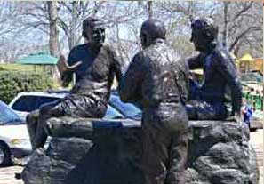

Roy Bedichek: One of Austin’s first Environmentalists
Quote Analysis Directions:
Read the following quote, discuss your interpretation with a learning partner and then answer the questions below in your notebook.

From the “Letters of Roy Bedichek” (1951)
“I think knowledge and love of one’s own immediate physical environment constitutes the very (and only) basis of genuine patriotism…Personally, if I have to fight for this country, I will not fight for the flag, or democracy, or private enterprise, or the American “way of life”, or for any other abstractions, which seem cold as kraut to me. But I will fight to the last ditch for Barton Creek, Boggy Creek, cedar-covered limestone hills, blazing stars and bluebonnets, golden-cheeked warblers and black-capped vireos, and so on through a catalogue of the natural environment of Austin, Texas. It is through this natural environment that I love America. Everything else is subsidiary for this love of your native land is basic.”
--Roy Bedichek (1878-1959)

Questions | Answers
1. Summarize the main ideas of this quote
2. What is patriotism? Why does Bedichek feel that knowledge & love of one’s environment is the most basic form of patriotism? Do you agree? Why or why not?
3.What other words or ideas are usually associated with the word, “Patriotism”? Is Bedichek’s view of Patriotism unique?
4.What is meant by the idea that other definitions of patriotism are subsidiary for his view of patriotism?
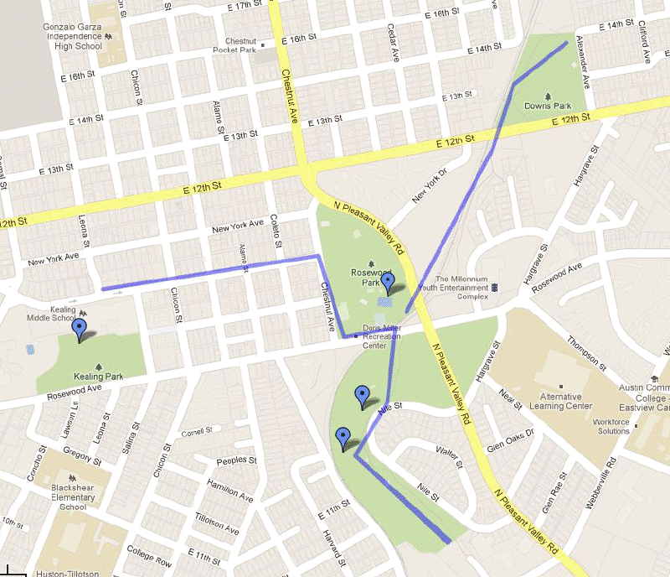
BOGGY CREEK GOOGLE MAP

